- Check your water softener or other in -home treatment device to insure that any drain lines have a proper air gap prior to entering the sewer line. The floor drain is considered a sewer line and there should be an air gap if the drain line runs into the floor drain.
How can I protect my family from cross connections?

Check all faucets where a hose might be connected and install a hose bib vacuum breaker to protect these connections.

- Install a Pressure Vacuum Breaker on your underground sprinklers and have it tested annually when the sprinklers are turned on for the season.

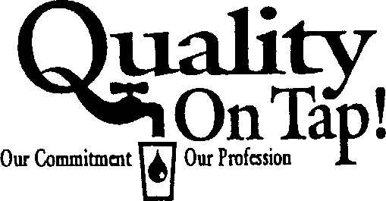
- If you have a boiler for home heating, make sure the fill line is protected with an approved backflow prevention assembly.

- If you have old-style sinks or bathtubs, be sure never to fill them so the water level is higher than the fill spout.
Published by:
Nebraska Rural Water Association
(10/2002)

PROTECTING OUR WATER IS A JOB FOR EVERYONE

BACKFLOW PREVENTION IN THE
HOUSEHOLD

Protecting Your Family and Your Community

rinking water is one of our most precious resources and it is the responsibility of everyone to protect
D
this vital commodity. There are many ways that our drinking water become polluted, and the most well known of these are caused by large chemical companies and industries that discard hazardous materials in an unsafe manner. Although these are the most advertised methods of polluting groundwater, the most numerous and avoidable sources of contamination are the result of cross connections.

What are cross connections?
A cross connection occurs whenever there is a physical connection between sources of contamination and the public drinking water supply. Sources of contamination can include hazardous as well as non-hazardous materials. Raw sewage and corrosion control chemicals used in boilers are examples of hazardous materials, while milk, orange juice and other edible substances are examples of non-hazardous materials.
Every house contains several cross connections. Sinks, bathtubs and toilets contain a physical connection between the sewer system and the water system, but current plumbing codes and standards require these devices to be protected by built in air gaps. Some older houses may still have the old washtub sinks and claw footed bathtubs where the faucets are below the overflow level of the fixture, and these are considered an unprotected cross connection. For the purpose of protecting the public water supply, it is the unprotected cross connections that we must address.

What causes cross connections?
Cross connections occur whenever water is needed for a specific purpose in the home. Unprotected cross connections are usually caused when the equipment for these purposes
are improperly
installed. Some cross
connections
are permanent
while others are temporary.
Examples of permanent cross connections are the fill line for a boiler used to heat a home, for swamp coolers and for water softeners and other home water treatment systems. These are usually piped right into the water system in the house and often there is no protection included in the installation. The drain line for water softeners are often plumbed directly into the sewer line of the home, which could result in raw sewage being siphoned back into the water pipes. Built in swimming pools, hot tubs, saunas, etc. are also examples of permanent type cross connections. Underground lawn sprinkler systems are a special case in Nebraska, but care should be taken to insure they do not contaminate the water.
The vast majority of temporary cross connections occur when hoses are connected to a faucet. Although the garden hose is the most common example of this type of cross connection, attaching hoses to sink faucets should not be overlooked. A sink sprayer that slips over the faucet is fairly common, and hoses used to fill and empty water beds also constitute a cross connection. Garden hoses are the most common unprotected cross connections. Washing a car, filling a baby pool,
irrigating a garden and spraying pesticides and fertilizer using a garden hose are several situations
where a garden hose might end up submerged
in a hazardous material. Although many lawn sprinklers are designed to have an air gap built in, soaker hoses and some low-profile sprinklers can end up submerged in water when used. Water toys, such as a slip-and-slide may also be a potential source of contamination.

Can cross connections affect me?
The affects of a backflow incident resulting from an unprotected cross connection can range from an upset stomach to serious illness or even death. It is suspected that many instances of “the flu that is going around” are in actuality the result of a backflow incident occurring due to a reduced or lost pressure incident in the water system.
Many water systems are starting to use a containment method to protect the system from contamination. This system consists of placing a backflow preventer on the service line prior to any water connection. Thereby keeping any contaminant on the premise from being able to get into the public water system. Although this method protects the public water system, it does not protect the residents of the service from getting a serious illness from a backflow incident on the premises. It is therefore very important for your family that you check your household plumbing to insure that there is no possibility of getting contamination from your house into the water your family drinks.

