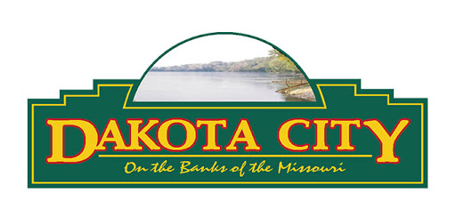
Snow Removal Technician
Don't worry about where you are going to be working this winter! Get on board now and then wait for the snow to fly!
As a snow removal technician, you are responsible for providing snow removal to City assets safely and efficiently. We are looking for a dynamic person who is excited to join the team and ready to jump into any situation to give a helping hand. If you are positive, reliable, adaptable, and hard-working; and have a genuine interest in the well-being of others around you, as well as the quality of your work, we encourage you to apply.
Experience with snow removal is a plus!
Submit application, resume and related information to the City of Dakota City, Attn: Street Supervisor, P.O. Box 482, Dakota City, NE 68731, or via email at maintenance@dakotacity.net.
Position open until filled.

