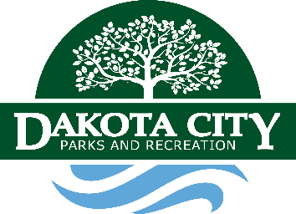
Welcome to Cottonwood Cove Park
On behalf of our Mayor, City Council & Parks & Recreation Board, we want to welcome you to Cottonwood Cove Park.
1. Quiet time is from 10:00 p.m. to 7:00 a.m.
2. Check out time is 1:00 p.m.
3. Camping fees can be paid: At City Hall located at 1511 Broadway Street. Our hours are Monday-Friday 8:00 a.m.-5:00 p.m. We are closed from 12:00 p.m. to 1:00 p.m. for lunch. Our number is 402-987-3448. Cash/Credit Cards are accepted at City Hall during business hours.
-Via credit card only at: dakotacity.net, Click other city payments, Select: weekly campground 7 days OR daily campground (6 days or less). Select available space (1-13).
Note: Must call City Hall at 402-987-3448 prior to making a reservation to confirm space availability. Phones are forwarded after hours. A map of campground spaces is located on our website.
5. Animals are welcome but must be leashed not to exceed 6’ in length. Clean up after your pet.
6. One 40 ft or less camper per family. Six persons maximum.
7. Use fire rings for your fires.
8. Campers with more than two (2) vehicles may park across the street on the north side of the park.
9. We have provided garbage containers for your use. Please help us keep the park clean.
10. Absolutely no dumping gray or black water in storm sewer. Dump station is at top of the hill and is free to paid campers. All others must contact City Hall at 402-987-3448 to utilize dump station for a fee of $5.00.
11. Please call City Hall at 402-987-3448 to get bathhouse security code.
12. Campers must be self-contained. No tent camping!
13. Yellow Reservation place card must be prominently displayed on your camper (facing inward).
14. To receive mail while camping, please direct mail to: Dakota City Post Office, General Delivery, C/O Campers Full Name, 110 N. 16th Street, Dakota City, NE 68731-9998. Must show valid ID at time of pickup.
In case of any emergency, please call 911. In case of severe weather (tornado, high winds, etc.), please go to our Fire Station located at 208 S. 21st Street. Please Park on the east side of the building. For any non-emergencies, you can call Dakota County Law Enforcement at 402-494-7555.

