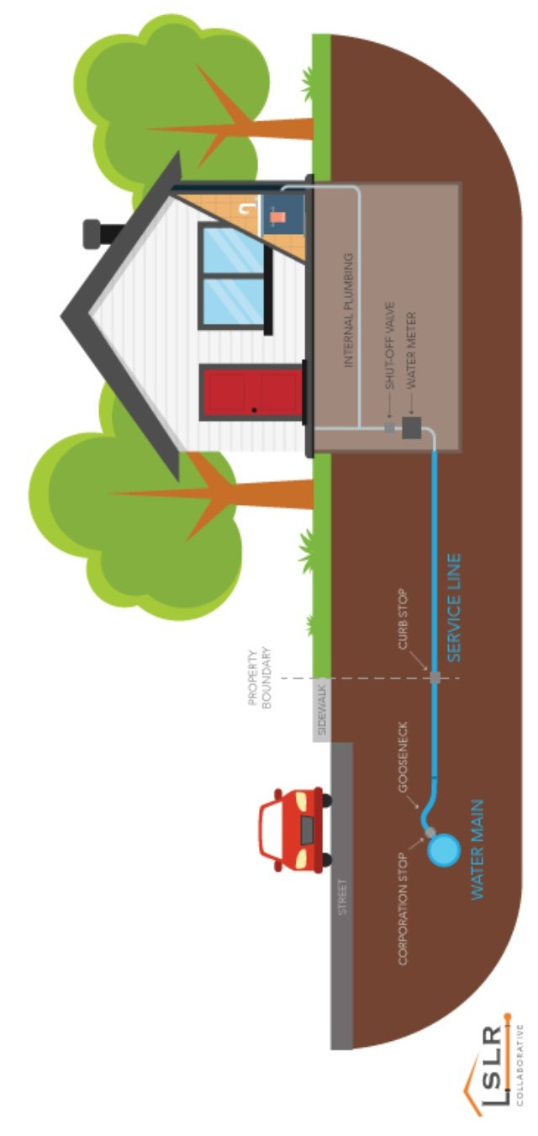

Do You Have a Lead Service Line?

Answer a few questions to protect your family’s health and help your utility identify the drinking water service line materials in your community
Adverse Health Effects of Lead Drinking water that contains lead can damage a developing brain. It is especially harmful for children 6 and
under and in adults, lead can increase blood pressure. With your help, your utility can reduce elevated levels of lead in your community.

Source of Lead
Your water system tests for lead levels regularly, but as you know, the source of lead in drinking water is often lead pipes and plumbing components in the distribution system that provides drinking water to your home.

Service Lines
Drinking water for your home is delivered from the water main to your home by a se rvice lin e . Service lines can contain lead. Identifying homes with lead service lines or lead components is crucial because corrosion of these materials over time can cause lead to accumulate in your drinking water.

Take Action Now
Be a part of the solution.
This is a large project and your utility needs your help!

How to Determine If I Have a Lead Service Check your r ecords. Have you completed maintenance on your service line? Do you
know when your home was built? If your home
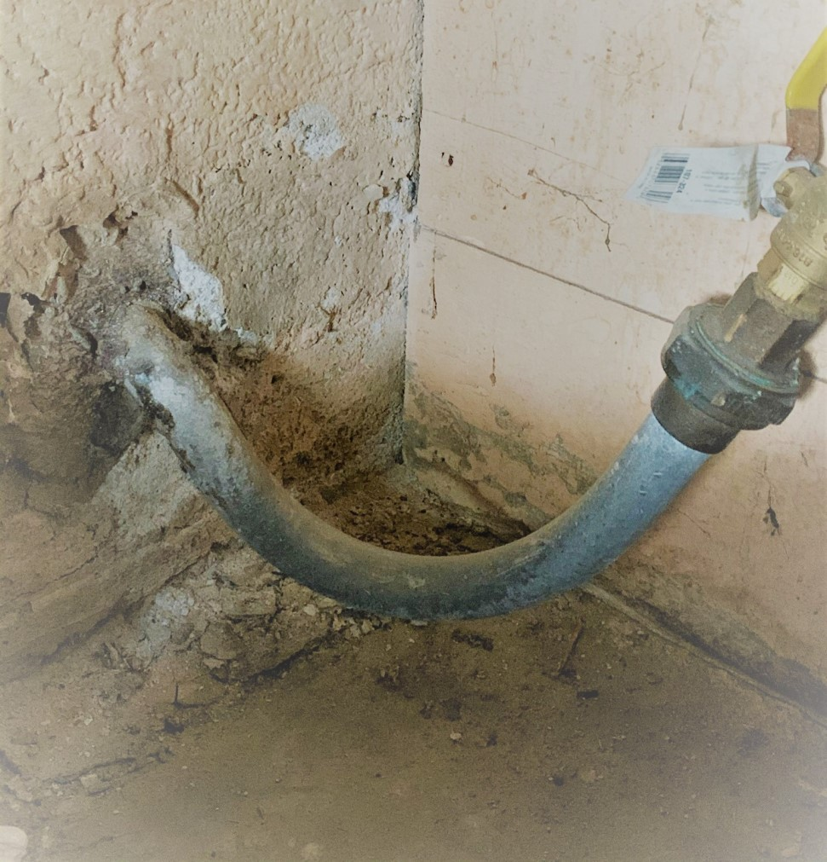is older than 1988 and has the original service line or plumbing, then your home may have a lead service line or a lead component.

Photo of lead service line in home in North Platte, NE.

I nspect the ser vice line your self . You can save time and money and inspect the service line yourself. These lines typically enter your home through the wall facing the street on the lowest level but each setup can be unique to each home. If you do not own your home, please
contact the homeowner for this information.
I s it Lead?

Start with a magnet or scratch test. Gently scratch the surface of the pipe with a coin. If the pipe is soft, easily scraped, silver, and a magnet doesn’t stick, it is most likely lead.

If Not Lead, T hen W hat ?

1. Does a magnet stick? If so and the line is dull grey when scratched, this portion of the service line is galvanized steel.
2. If the magnet doesn't stick, it is same color as a penny when scratched or has greenish blue build up, this portion of the service line is copper.
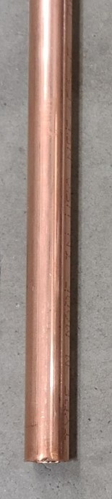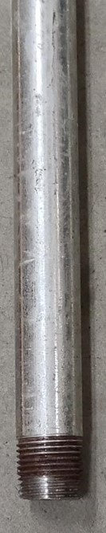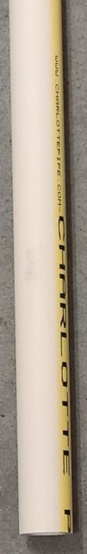3. If the magnet doesn't stick, it is white-ish yellow or grey, is joined with a clamp, screw or glue, this portion of the service line is plastic or Chlorinated polyvinyl chloride (CPVC).

If you are still unsure about the materials present and have questions contact us.

Please Provide the Following
Information

Name:

Address:
Year home was built: Is the original Service Line material still
present? (Yes, No or Unknown):

Service Line Material (Lead, Non-Lead, Galvanized or Unknown):

Are there other Lead Materials present? (Unknown, None, Goose Neck, Pig Tail, or other):

Once complete, please return this flyer to your water utility
City of Dakota City
P O Box 482
Dakota City NE 68731

Sources: EPA.gov, Lead Service Line Replacement Collaborative,“How Can I Find Out If I Have a Lead Service Line?” Betanzo, 2020.

